(27-09-22) C++ program

OBJECT ORIENTED PROGRAMMING -C++:DSA0136

1.**program for addition of two numbers using class**

#include<iostream>

using namespace std;

class SUM

{

int a,b,c;

public:

void getdata()

{

cout<<"enter two values:";

cin>>a>>b;

}

void putdata()

{

cout<<"sum of two numbers:";

c = a+b;

cout<<c;

}

};

main()

{

SUM s;

s.getdata();

s.putdata();

}

Output:

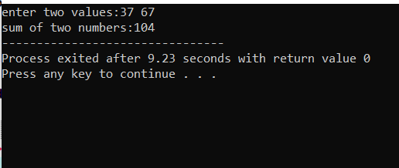

**2.program to find the biggest number using class and object**

#include<iostream>

using namespace std;

class big

{

int x,y,z;

public:

void getdata();

};

void big:: getdata()

{

cout<<"enter three values:";

cin>>x>>y>>z;

if(int(x)&&int(y)&&int(z))

{

if(x>y&&x>z)

cout<<x<<"is biggest";

else if(y>z&&y>x)

cout<<y<<"is biggest";

else

cout<<z<<"is greatest";

}

else

cout<<"enter correct input";

}

main()

{

Big b;

b.getdata();

}

Output:

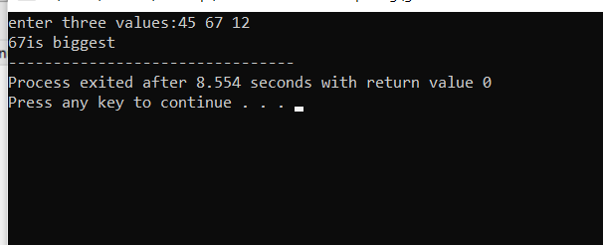

**3.program for arthmatic operations using class**

#include<iostream>

using namespace std;

class operation

{

int a,b,choice,sum,sub,mul;

float div;

public:

void getdata()

{

cout<<"enter a and b values:";

cin>>a>>b;

}

void putdata()

{

cout<<"enter choice:";

cin>>choice;

switch(choice)

{

case 1:

cout<<"The Addition result is "<<a+b;

break;

case 2:

cout<<"The subtraction is"<<a-b;

break;

case 3:

cout<<"The multiplication is"<<a*b;

break;

case 4:

cout<<"The division is"<<a/b;

break;

default:

cout<<"enter correct choice";

break;}

}

};

main()

{operation o;

o.getdata();

o.putdata();

}

Output:

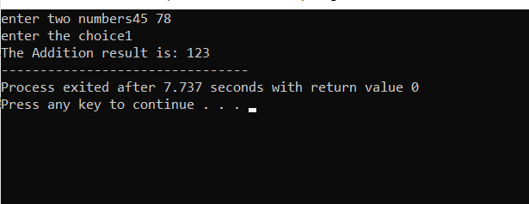

**4.program about the function overloading with class**

#include <iostream>

using namespace std;

class Cal {

public:

int add(int a,int b){

return a + b;

}

float add(int a, float b, float c)

{ return a + b + c;

}

};

int main() {

Cal C;

cout<<C.add(10, 20)<<endl;

cout<<C.add(12, 2.7,56.8);

return 0;

}

Output:

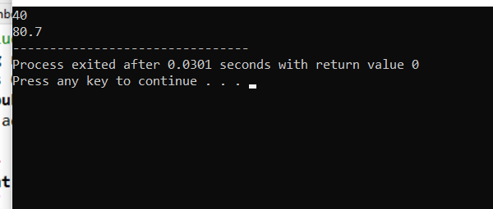

**5.program to find the student report**

#include<iostream>

using namespace std;

main()

{

int m1,m2,m3,avg,total;

char name[20];

cout<<"enter m1,m2,m3";

cin>>m1>>m2>>m3;

total=m1+m2+m3;

cout<<"total = "<<total;

avg=total/3;

cout<<"average is = "<<avg;

if(m1>=50&&m2>50&&m3>50)

if(avg>=90)

cout<<"A grade";

else if(90>avg>80)

cout<<"B grade";

else if("70>avg>80")

cout<<"C grade";

else if(60>avg>70)

cout<<" no grade";

else if(avg<50)

cout<<"fail";

}

Output:

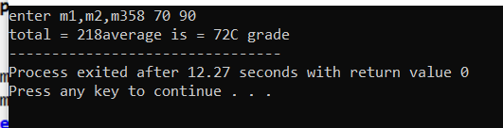

**6.program for swapping of numbers using call by value**

#include <iostream>

using namespace std;

void change(int data);

int main()

{

int data = 7;

change(data);

cout<< "Value of the data is: " << data<<endl;

return 0;

}

void change(int data)

{

data = 17;

}

Output:

